
Mrs. Keri, Ms. Brenda, Mrs. Brooke & Ms. Kadee’s Weekly Buzz
August 30-September 3, 2021
Dates to Remember:
September 3: caps for a cure & wear gold; please send in $1 (all proceeds go to cure childhood cancer)
September 6: no school; labor day
September 13-17: our book fair
September 13: virtual grandparents’ day
September 15: grant’s birthday
Our Week In Review
We have enjoyed the books The Fully Belly Bowl, Lola at the Library and many more. In Math we have worked with five frames and counting objects. Our math problem of the week was “There are 6 boys in front of you and 3 girls behind you. How many children are in the line? How many classmates are not in the line?”
Also, we started Reading Eggs this week. It is an online learning program. Students can explore a game-like learning world where they work at their own academic level to build reading and comprehension skills. Your child will be using this program at school, but he or she can also continue learning at home.
Today, we are sending home their at-home login codes.

In the book, The full belly bowl, an elderly man received a bowl that would make infinite amounts of whatever item was placed in the bowl. “What item would you put into your full belly bowl?”
Grant: money Leland: my cat Keke: Salt & Vinegar Chips Sam: my bike Elijah: alligators Anna Claire: Nintendo switch Finn: Ipad
Kayden: sharks! Gabe: my house, I want losts of houses Alice: a book Sophie: Quarters
Neriah: a cat Mrs. Kadee: diet coke
Mrs. Brenda: French fries Camari: unicorn candy Marcus: a hammerhead shark
De’Kari: basketball Jax: Dollars! All the dollars until I get to 1 Million! Mrs. Brooke: Cheese


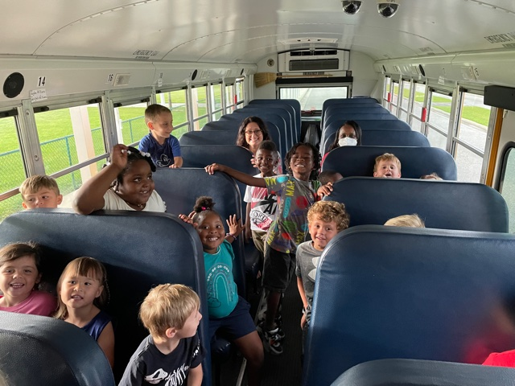
Quarters for a CURE

Our school is collecting quarters (or any other kind of money donated) for Relay for Life. We will collect them for the month of September. CURE is an organization based in GA that helps families affected by childhood cancer. At the end of September the class that raised the most money will get to have a party!

Bus Safety!

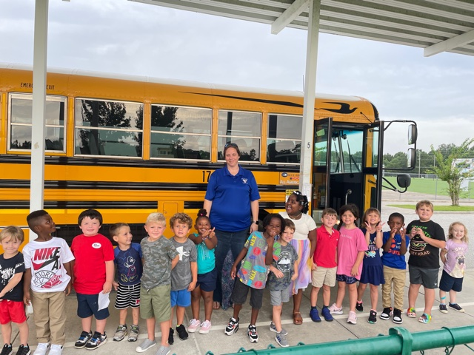

This week’s sight words:
the of

